**Practical 7 Report**

Submitted by:

**Name: Yeo Beng Wah**

**Student ID: P7351399**

1. I have created an account in Heroku with my ‘business’ email and set up an app with the name it8832-practical7; as shown:

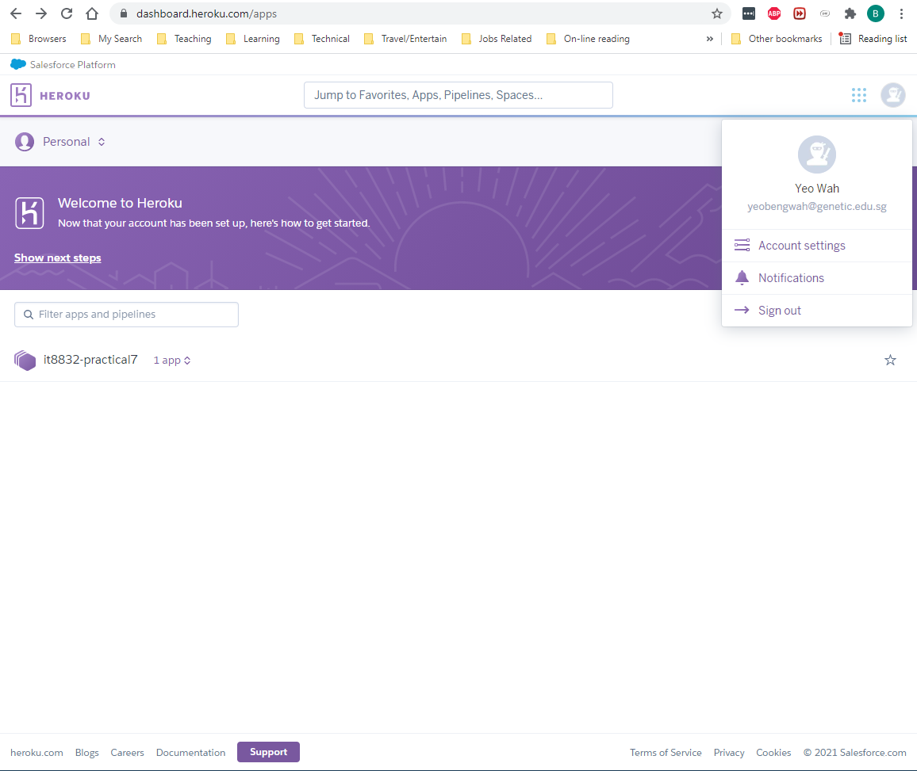

1. The following screen shows that I successfully created the JawsDB MySQL add-on:

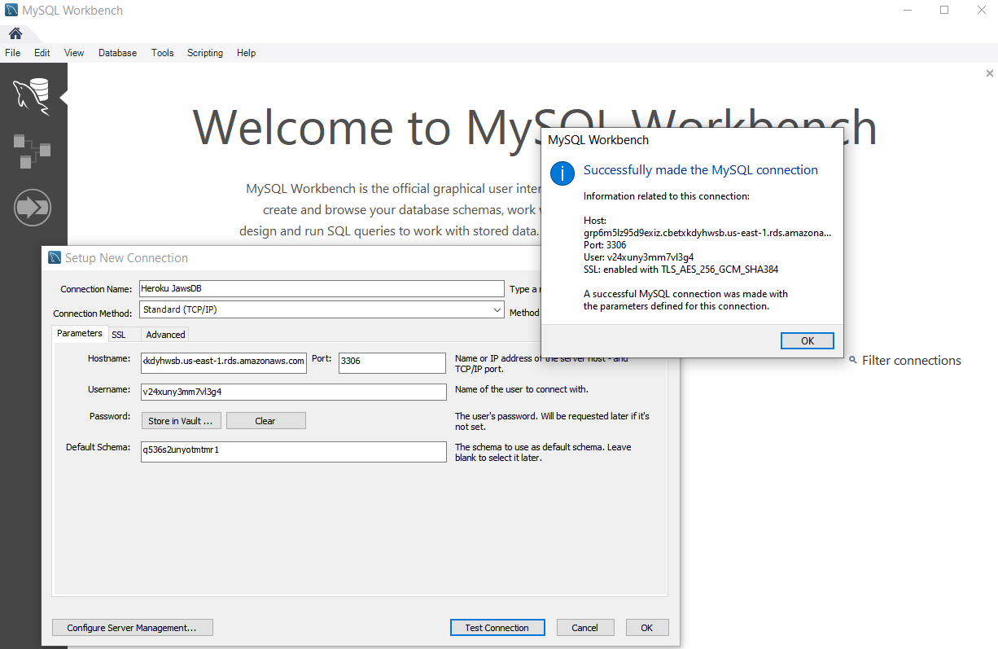

1. I have created the user table with data enties into the Heroku JawsDB schemas. So have done setting up the database.

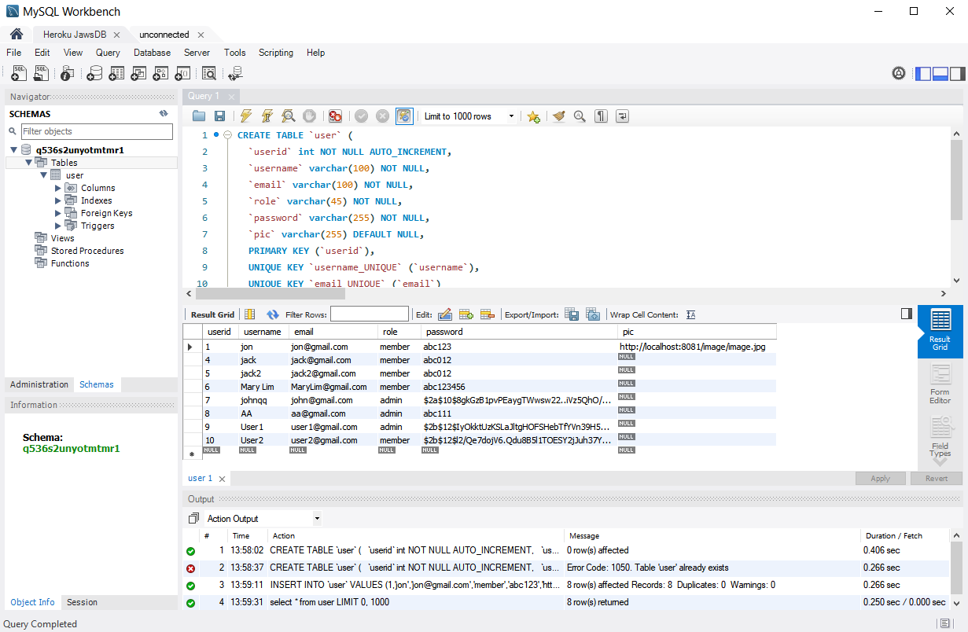

1. Preparing files for hosting:

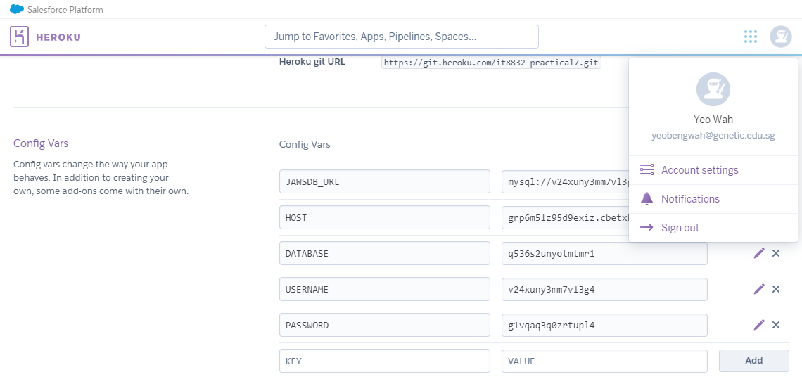

1. The following text file requirements.txt is created with minimum libraries:

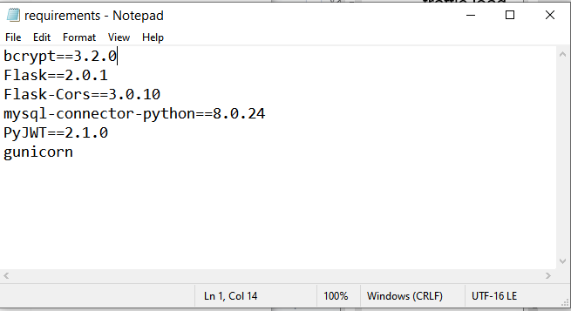

1. Create a new file Procfile with no file extension:

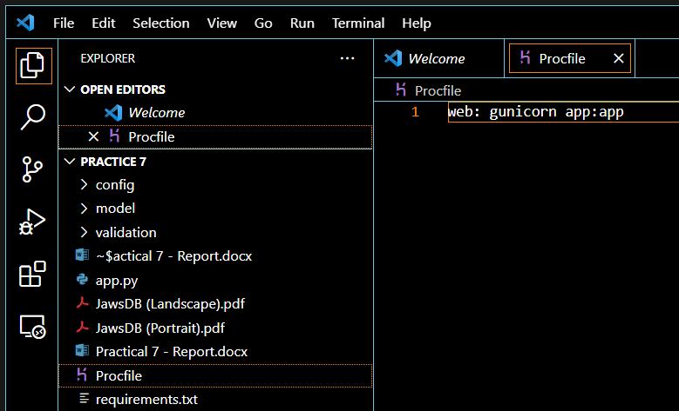

1. Edit the Setting.py as shown:

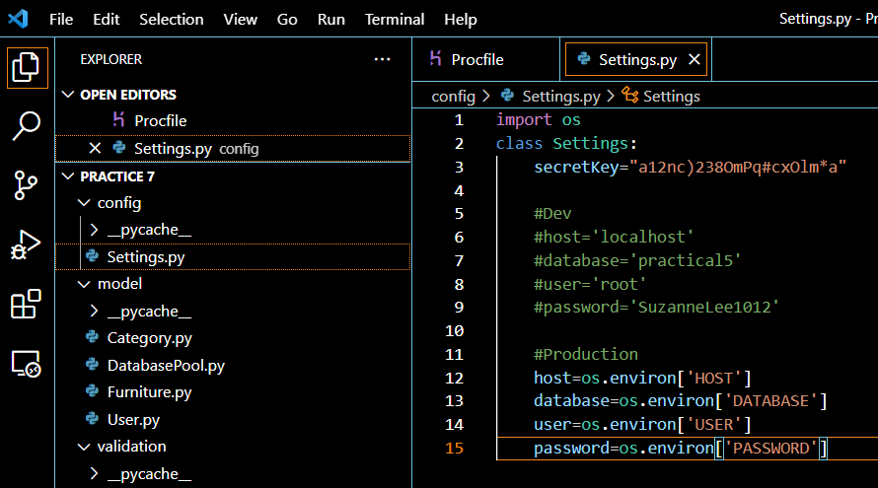

1. Edit the DatabasePool.py with the following code:

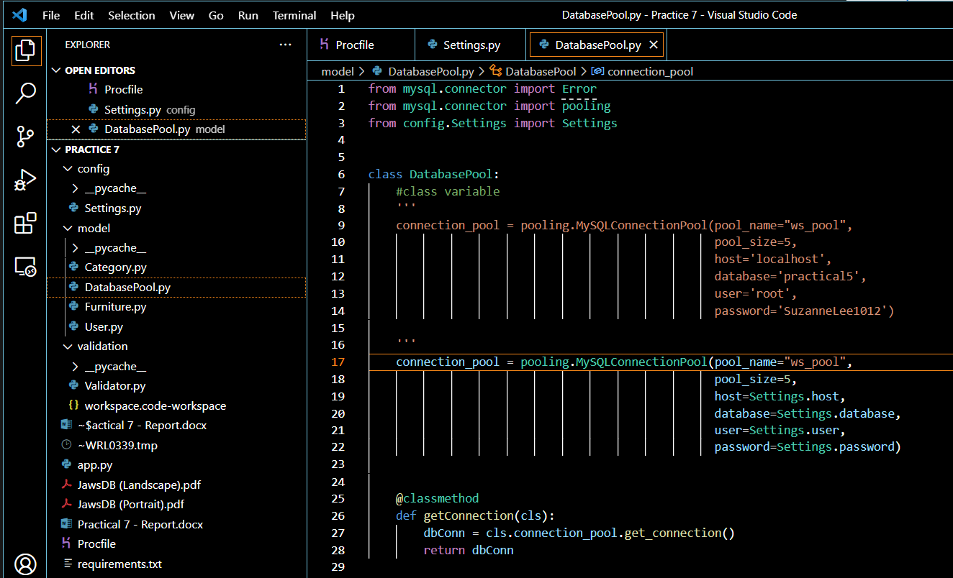

1. Setting up the GitHub:

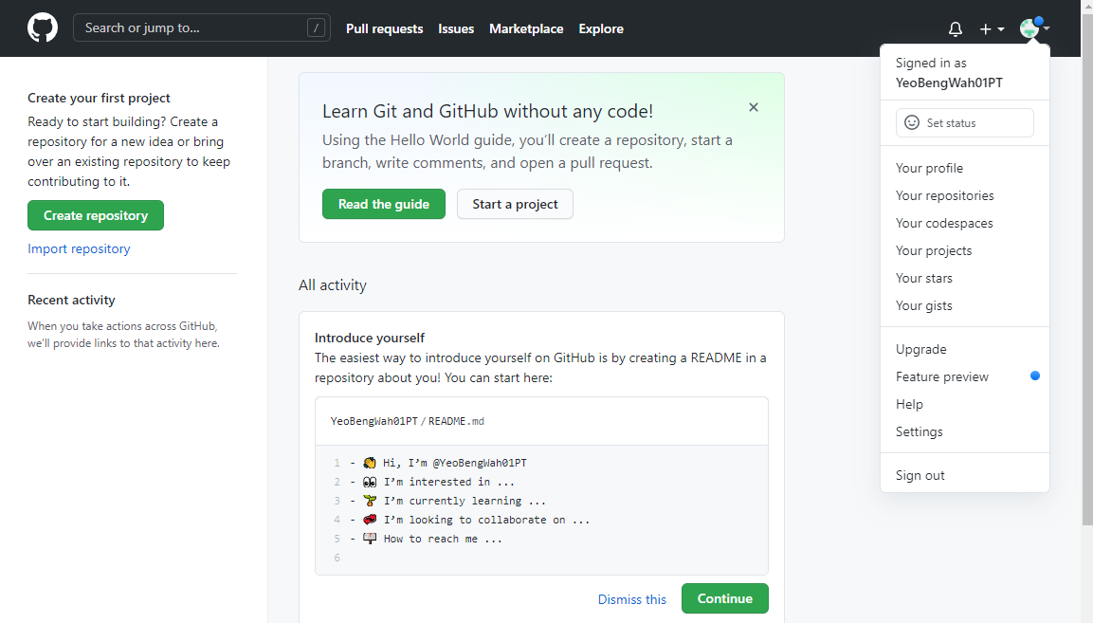

1. Next, creating new Repository with the name: flaskHeroku

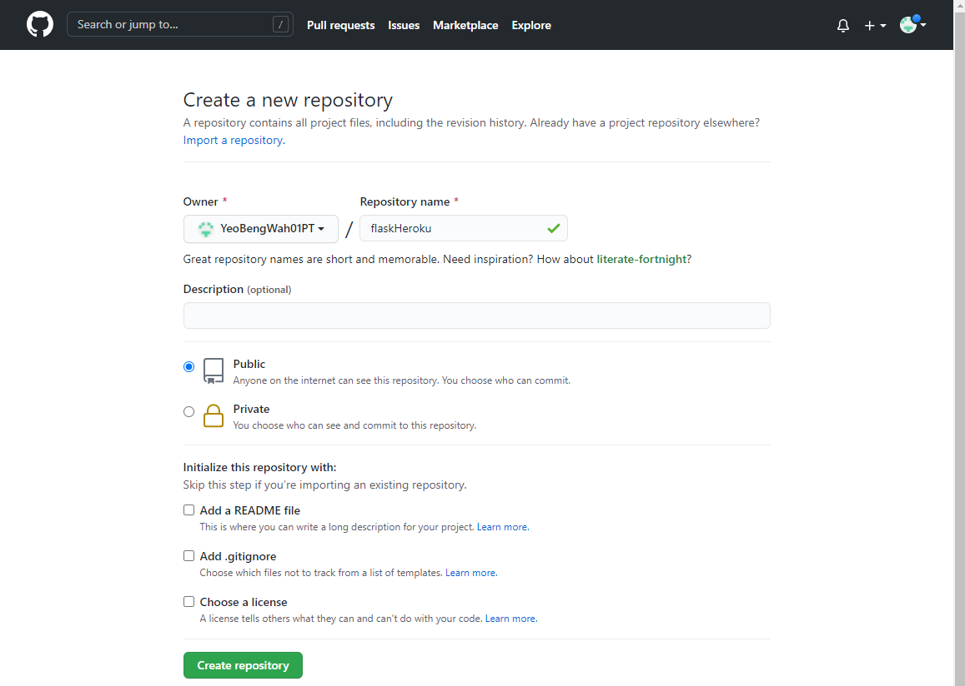

1. The following shows the screen shoot after the creation of Repository:

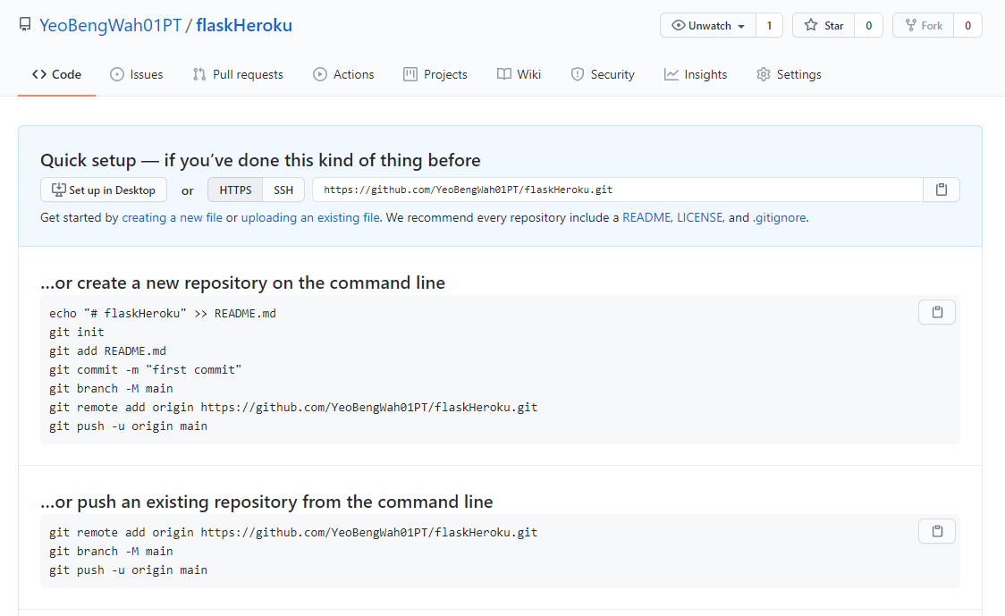

1. File with name .gitignore is created with the following contents:

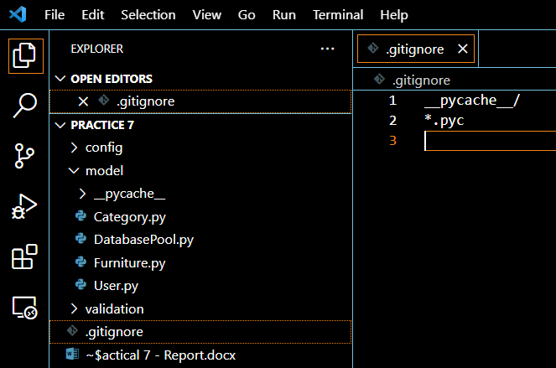

1. After running the git commands as per instructed from the Practical 7 file (i.e.):

git init

git add *

git commit -m "V1 app"

git branch -M main

git remote add origin <replace with your github repo url>

git push -u origin main

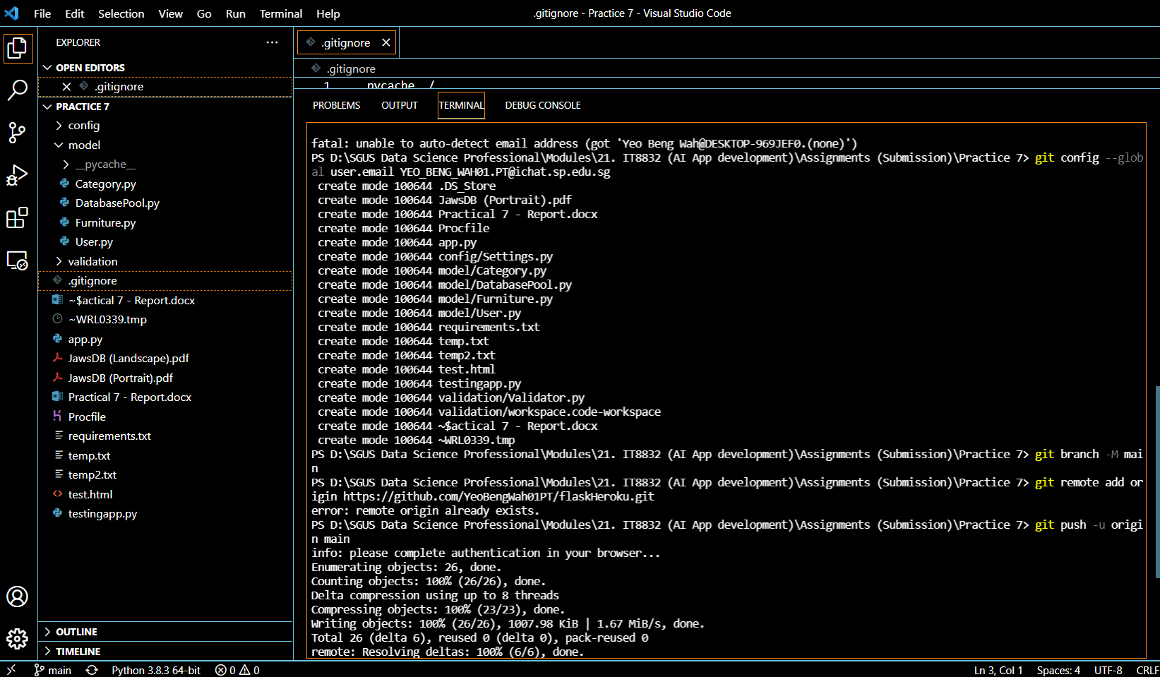

I have all the files updated into GIT as shown:

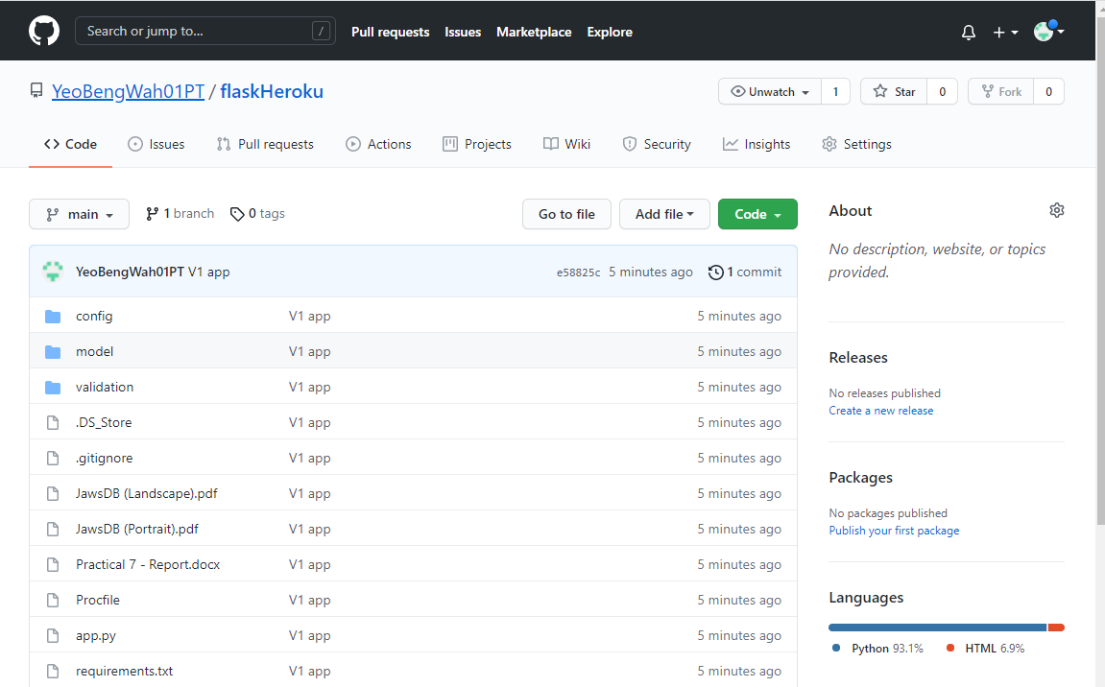

1. Back to Herorku dashboard and click the Deploy tab:

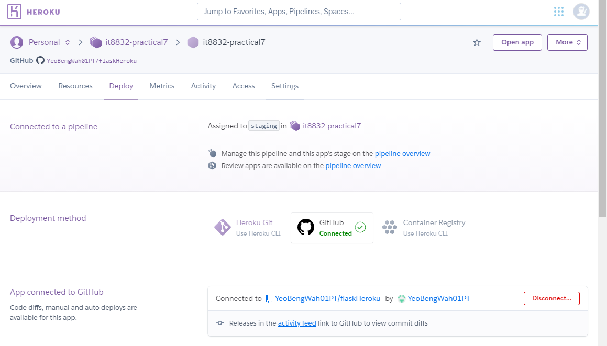

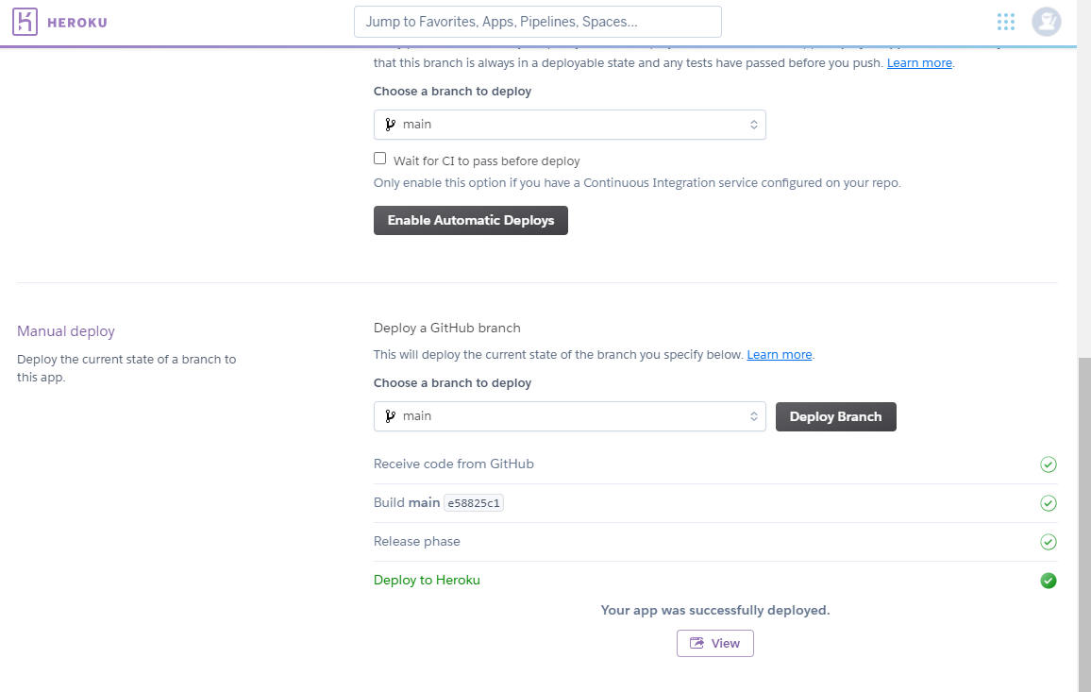

The following is the log:

